Executor
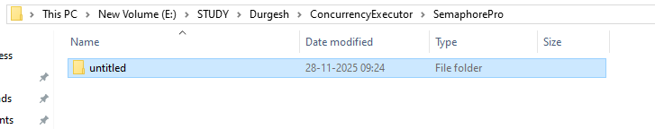
Security part1 pro
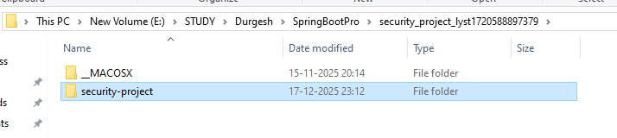
Secutiry Project part2
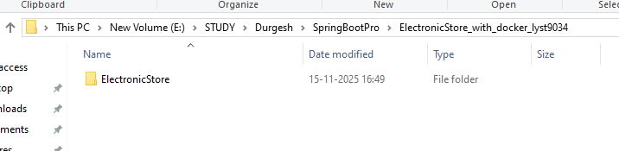
Microservices Tut
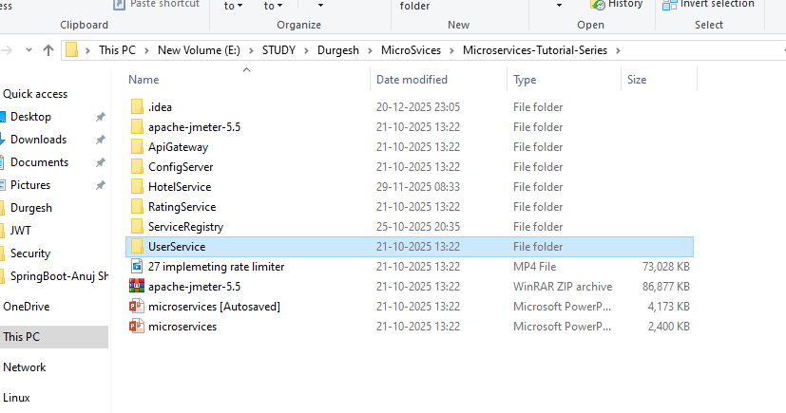
Spring AI
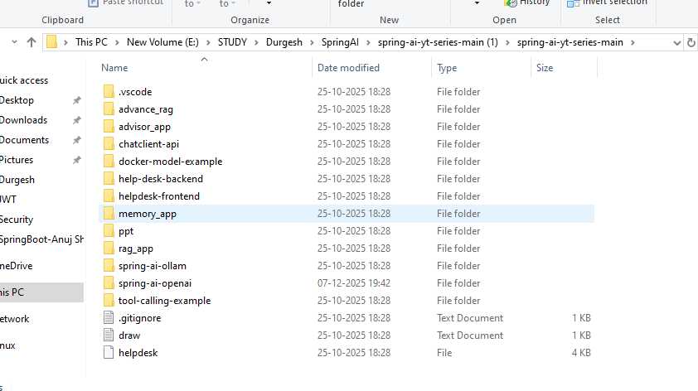
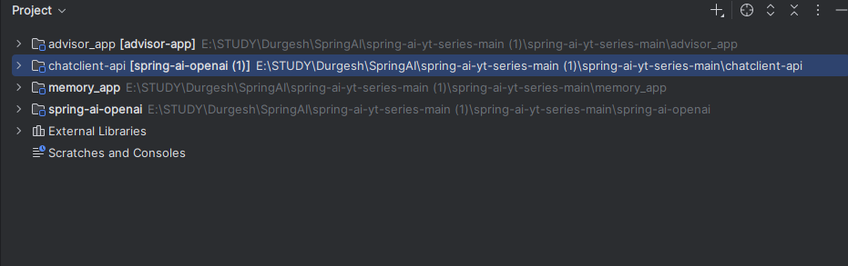
Elemntry Program
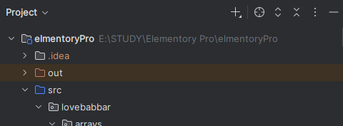
Stream
